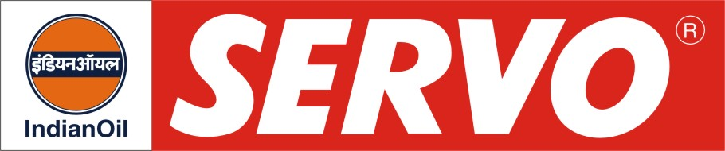
GRADES AVAILABLE - SERVO GEAR ALT 140

DESCRIPTION

Servo Gear ALT 140 oil is an extreme pressure automotive gear lubricant. This oil is blended from selected base stocks and contain additives to provide extreme pressure, anti-rust-corrosion characteristics.

APPLICATION

Servo Gear ALT 140 oil is recommended for Ashok Leyland commercial vehicles with spiral-bevel type rear axles.

PERFORMANCE STANDARDS

Servo Gear ALT 140 oil meets:
- API Service GL 4

APPROVAL

- Ashok Leyland Ltd., Chennai-Oil change period every 24000 Kms.

PERFORMANCE BENEFITS

Servo Gear ALT 140 oil

- Satisfy the lubrication requirements of a wide variety of gears.
- Provide protection against wear, due to good EP characteristics
- Give long service life even under high temperature operation since it has excellent oxidation stability
- Provide good protection against corrosion

CHARACTERISTICS

SAE GRADE | ALT 140
Kinematic Viscosity cSt @ 100°C | 28-34
Viscosity Index, Min. | 90
Flash point (COC), °C Min. | 190
Pour Point, °C Max. | 0

